**Final Project**

**Homework App**

This application was written with angular framework. It’s similar to Google class app but no saw the world. I decided to deploy it in Azure cloud for my practice to work with cloud technology.

Tools: Githab / Terraform / Azure

**1. Create infrastructure**

Azure DevOps → first_project → Repos → Infrastructure

Create file **main.tf** for deploying artifact and file **variables.tf** with vars

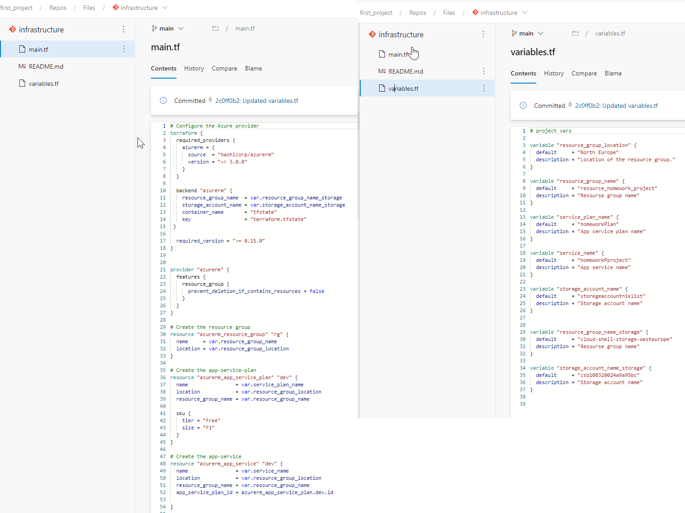

**2. Create pipeline for future infrastructure artifact**

Pipelines → Pipelines

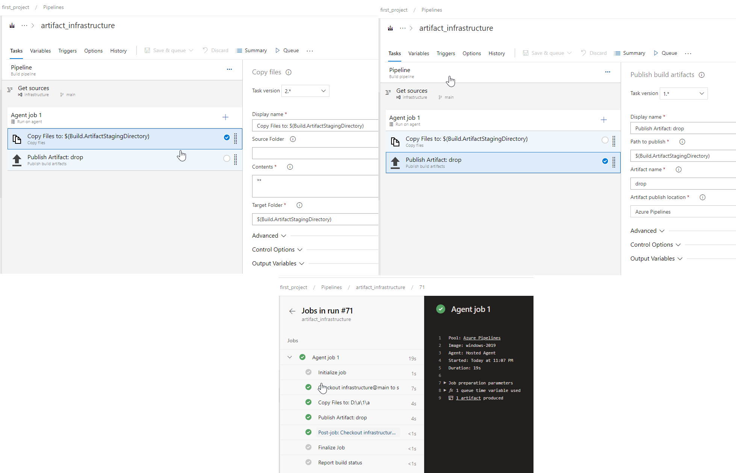

**3. Create pipeline for deploying infrastructure**

Pipelines → Release

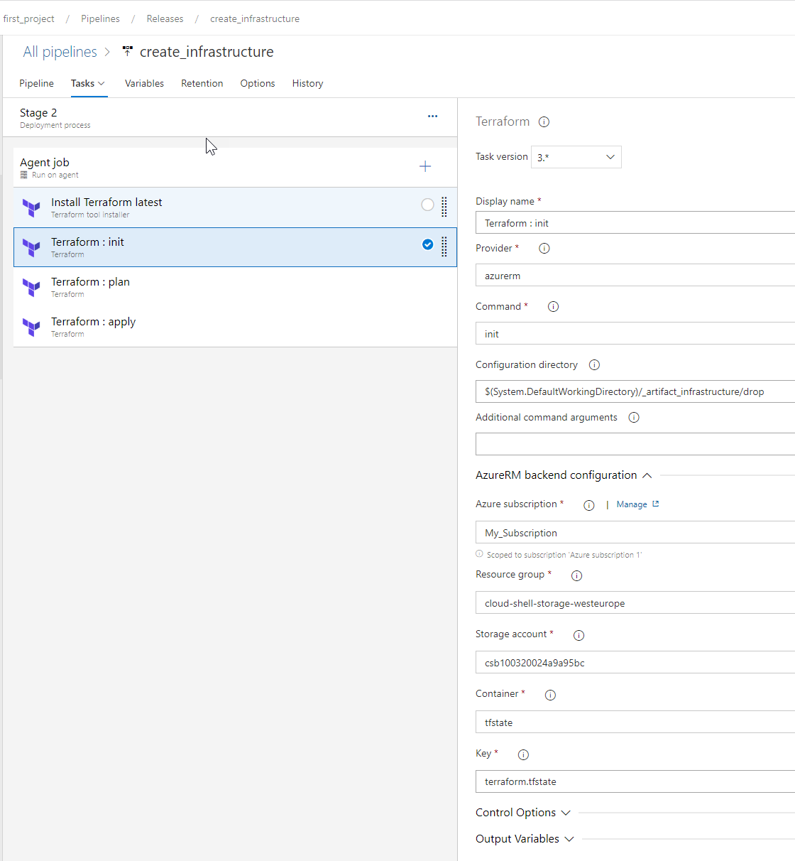

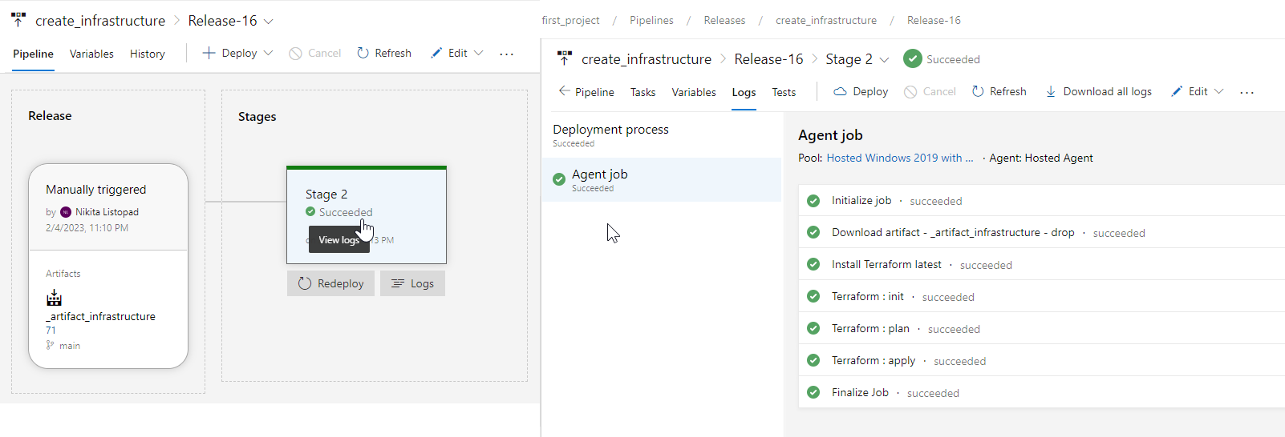

**4. Terraform state file I created in default resource group and storage account**

cloud-shell-storage-westeurope → csb100320024a9a95bc → containers → ftstate → terraform.tfstate

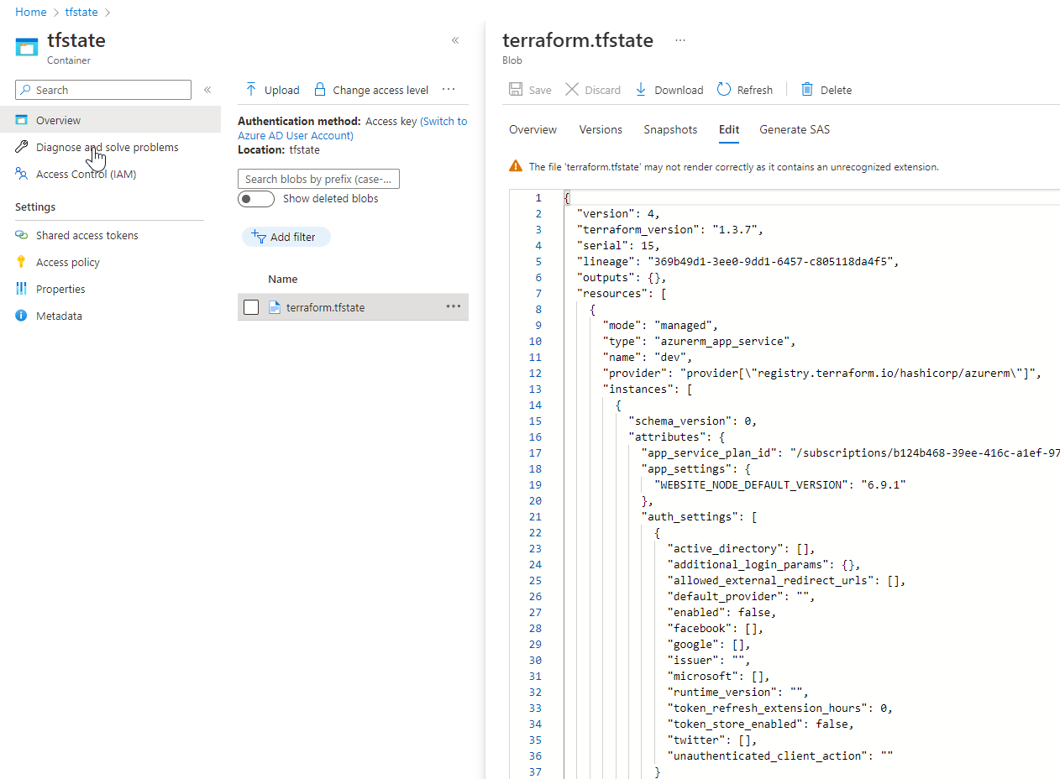

Result:

* created resource group: **resource_homework_project**
* created web app: **homeworkProject**
* created and wrote tfstate file: **terraform.tfstate**

**5. Create artifact for Web App: Homework**

Pipeline → New pipeline

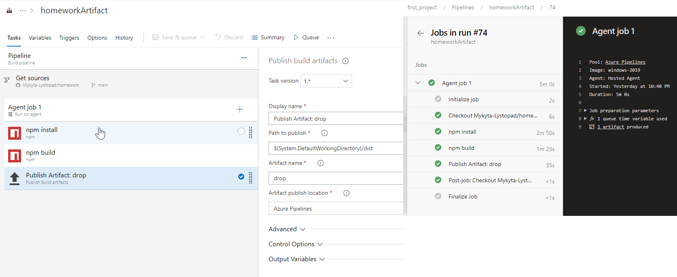

**6. Deploy web app - Homework**

Pipeline → Releases

**6.1 Add homeworkArtifact**

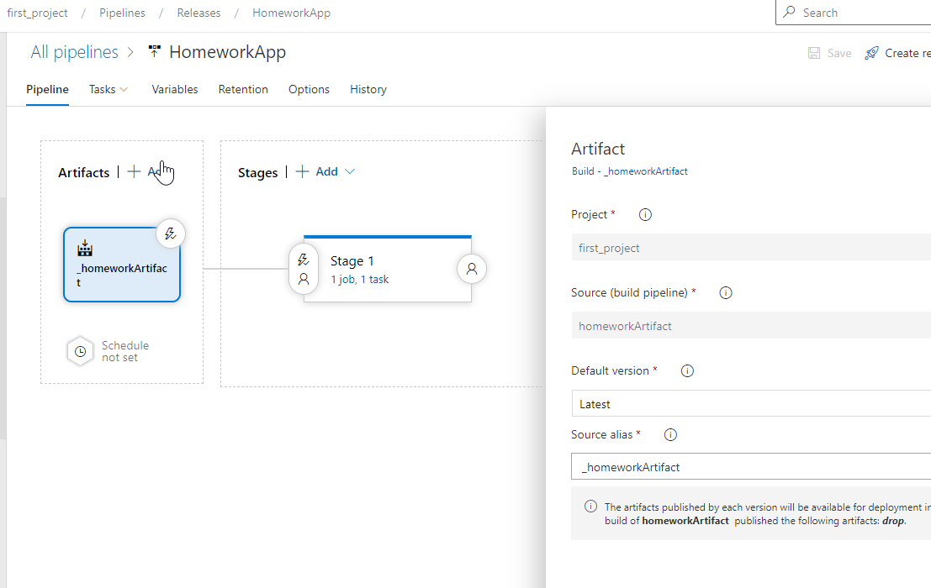

**6.2 Add task for deploy Homework Application**

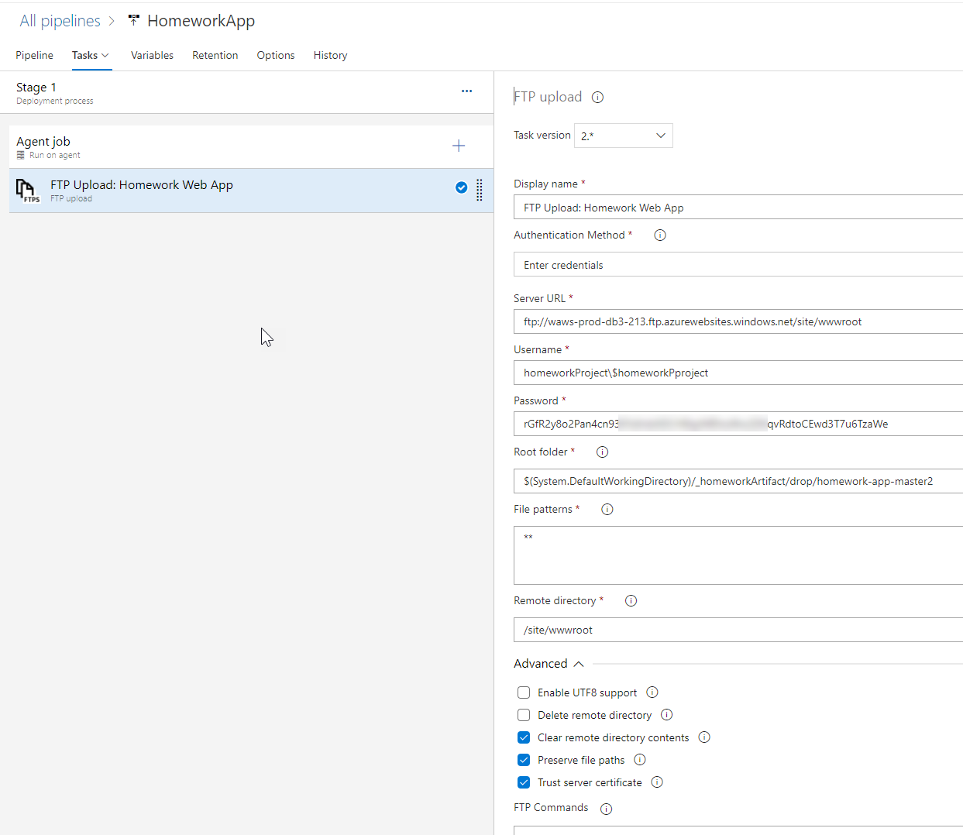

**7. Check CI/CD**

Did some changes in githab → artifact starts to update

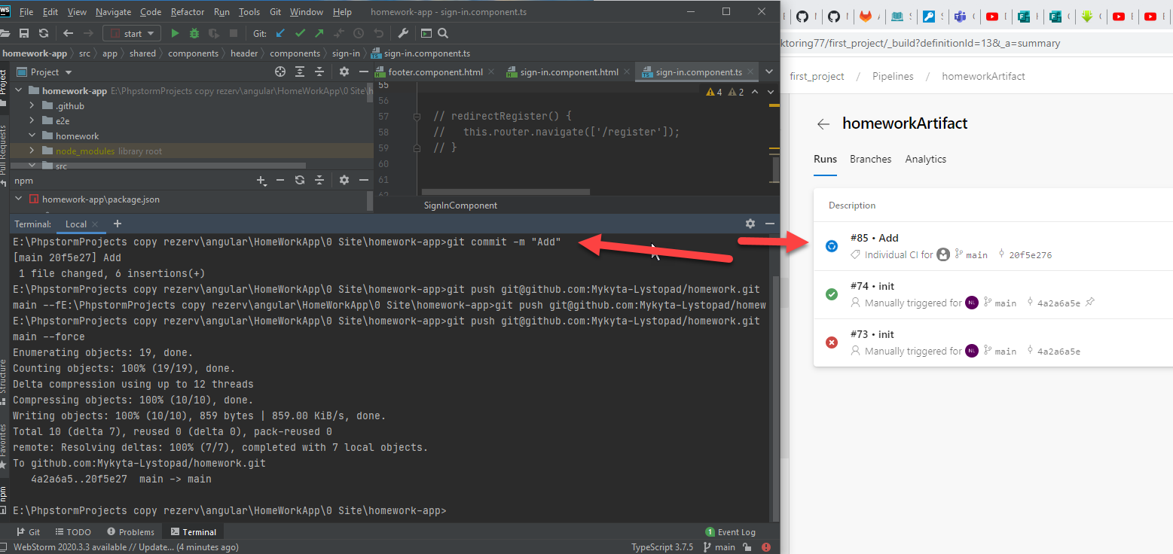

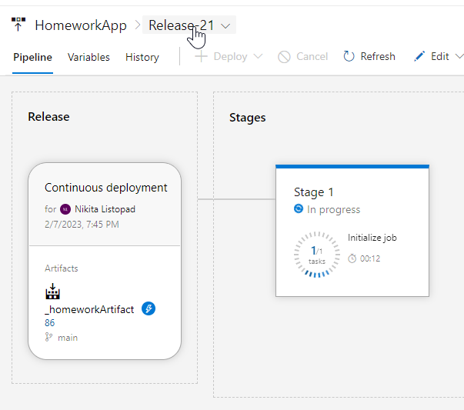

**Result:**

https://homeworkpproject.azurewebsites.net

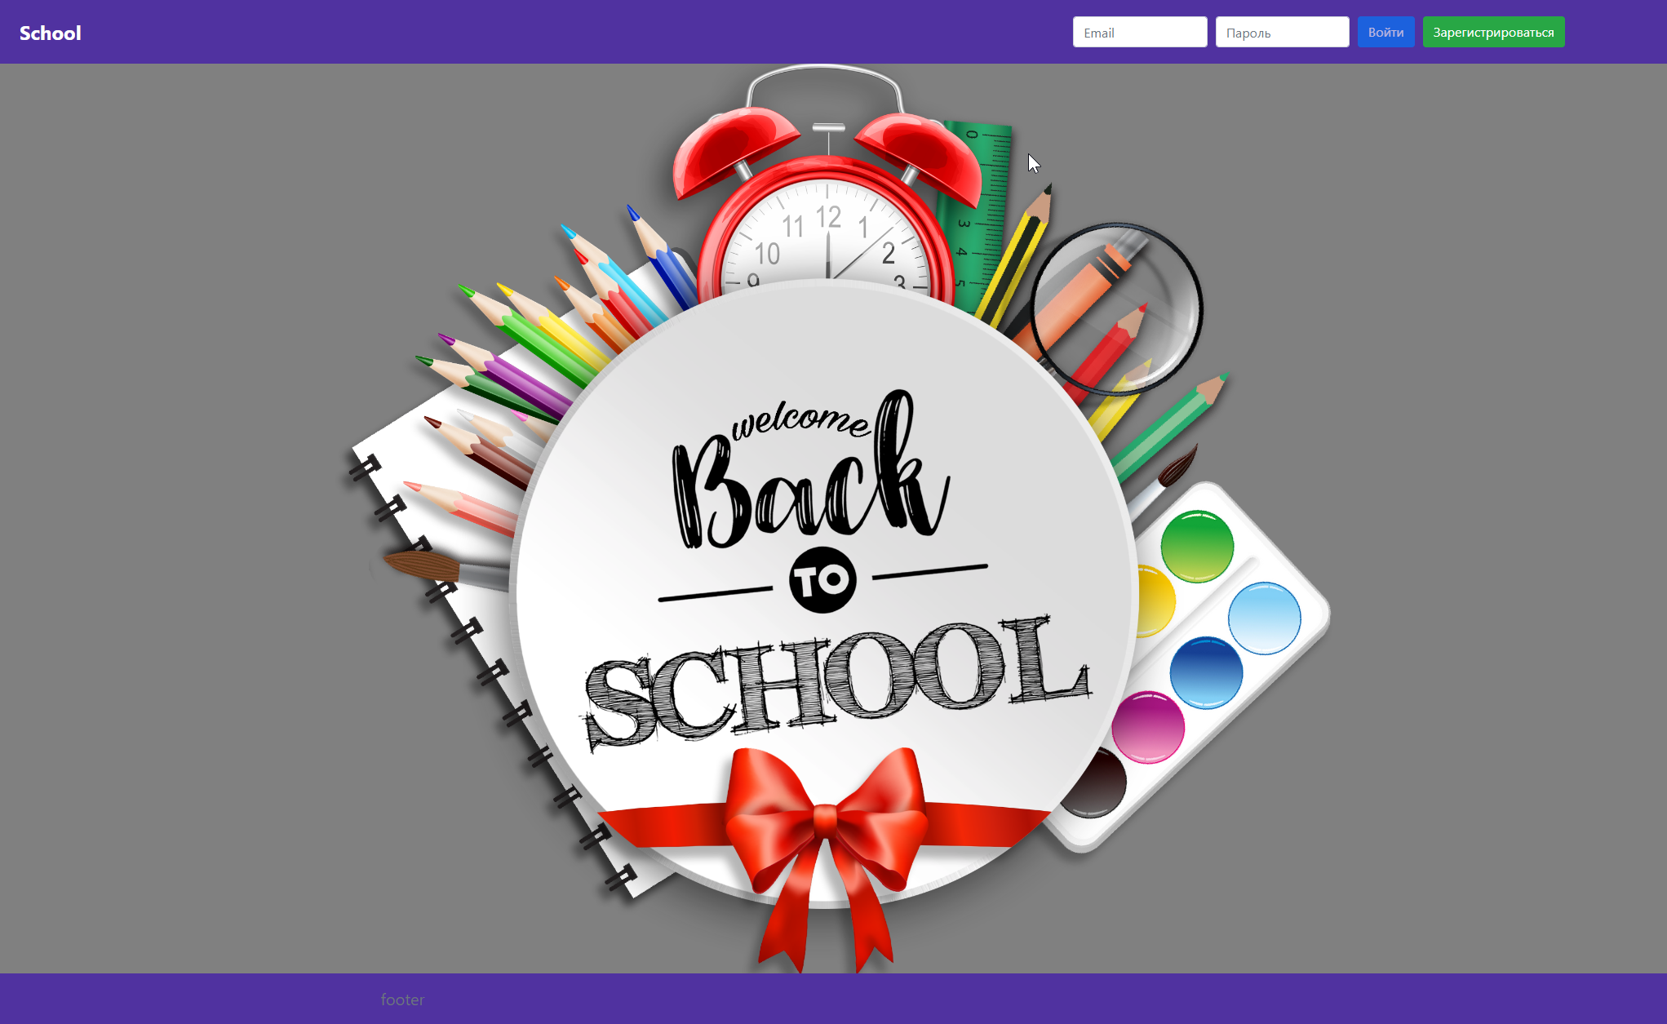

**8. Deploy backend app - “Homework Backend” for Homework application**

**8.1 Create resource group - laravel_backend**

**8.2 Create Web App - laravelHomework**

**8.3 Connect Github repo and create deploy yaml file**

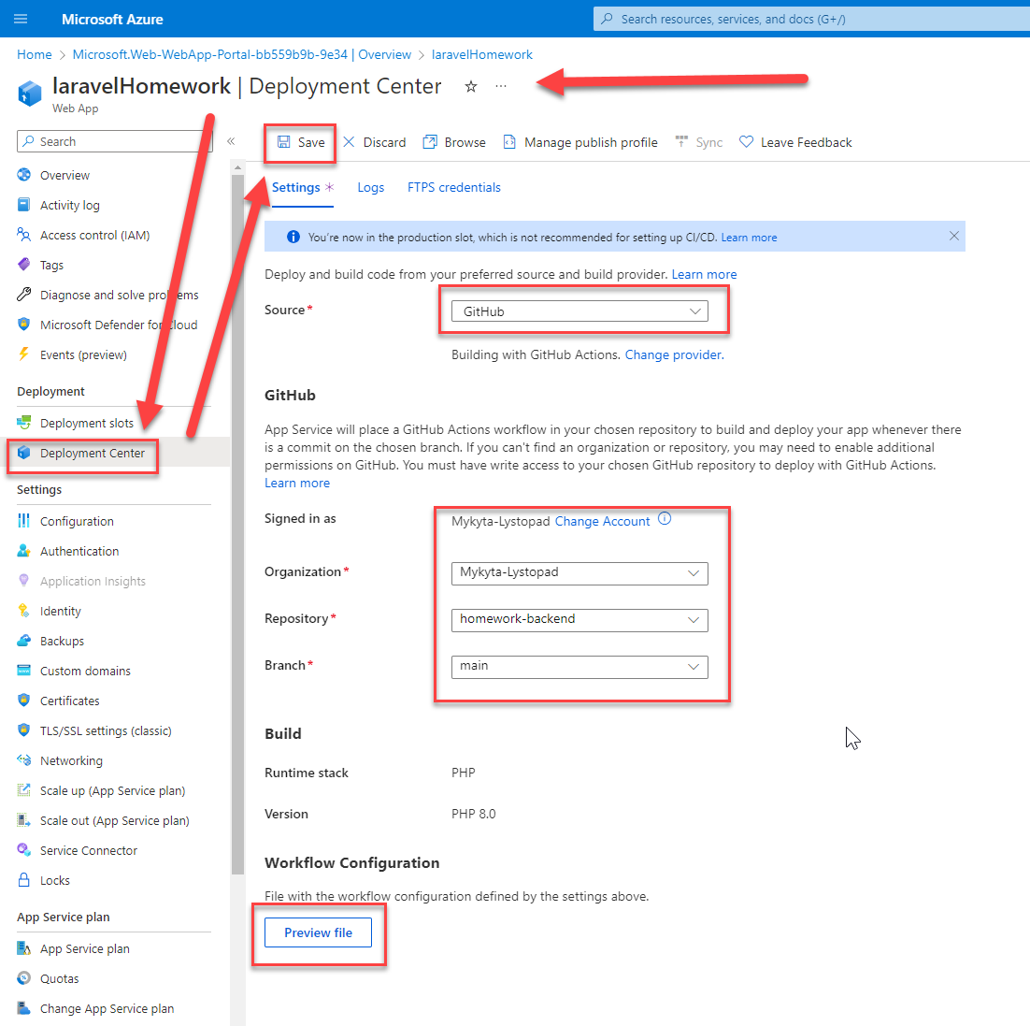

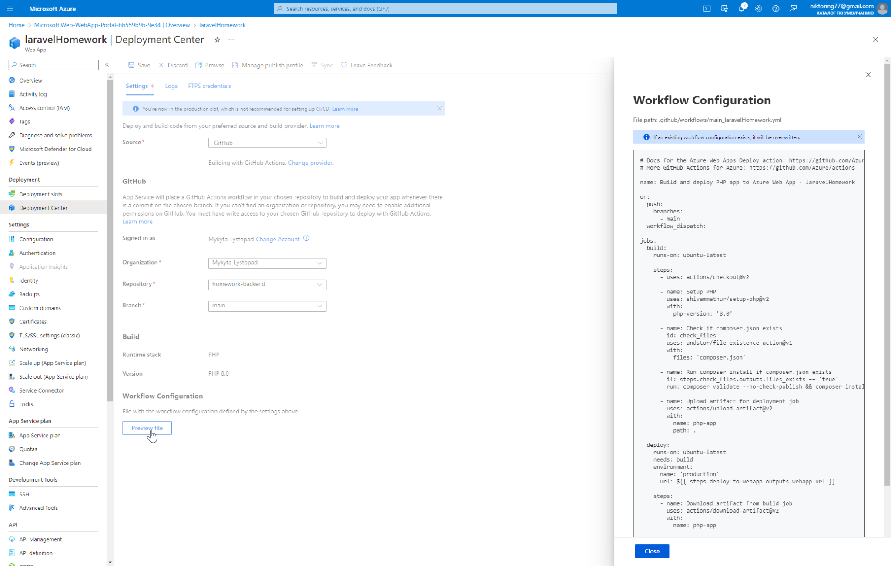

**8.4 Using Github Actions**

First of all I have to delete all writes in composer.lock file because it was the cause of errors

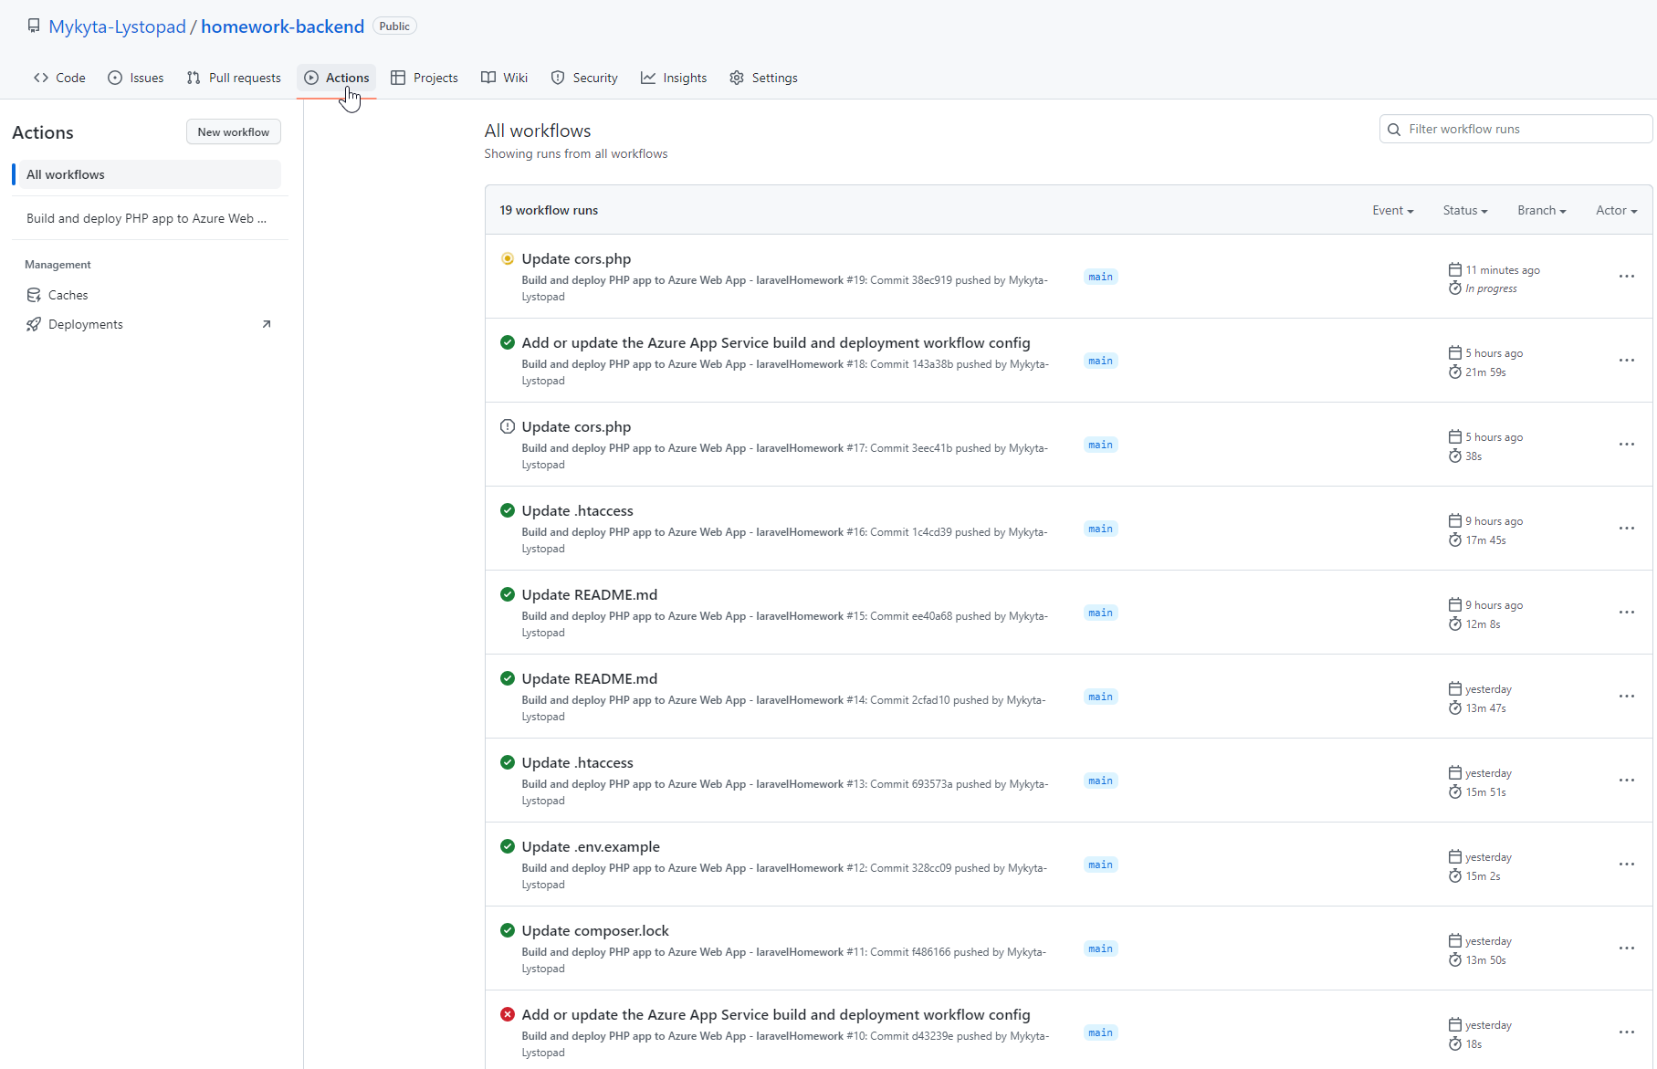

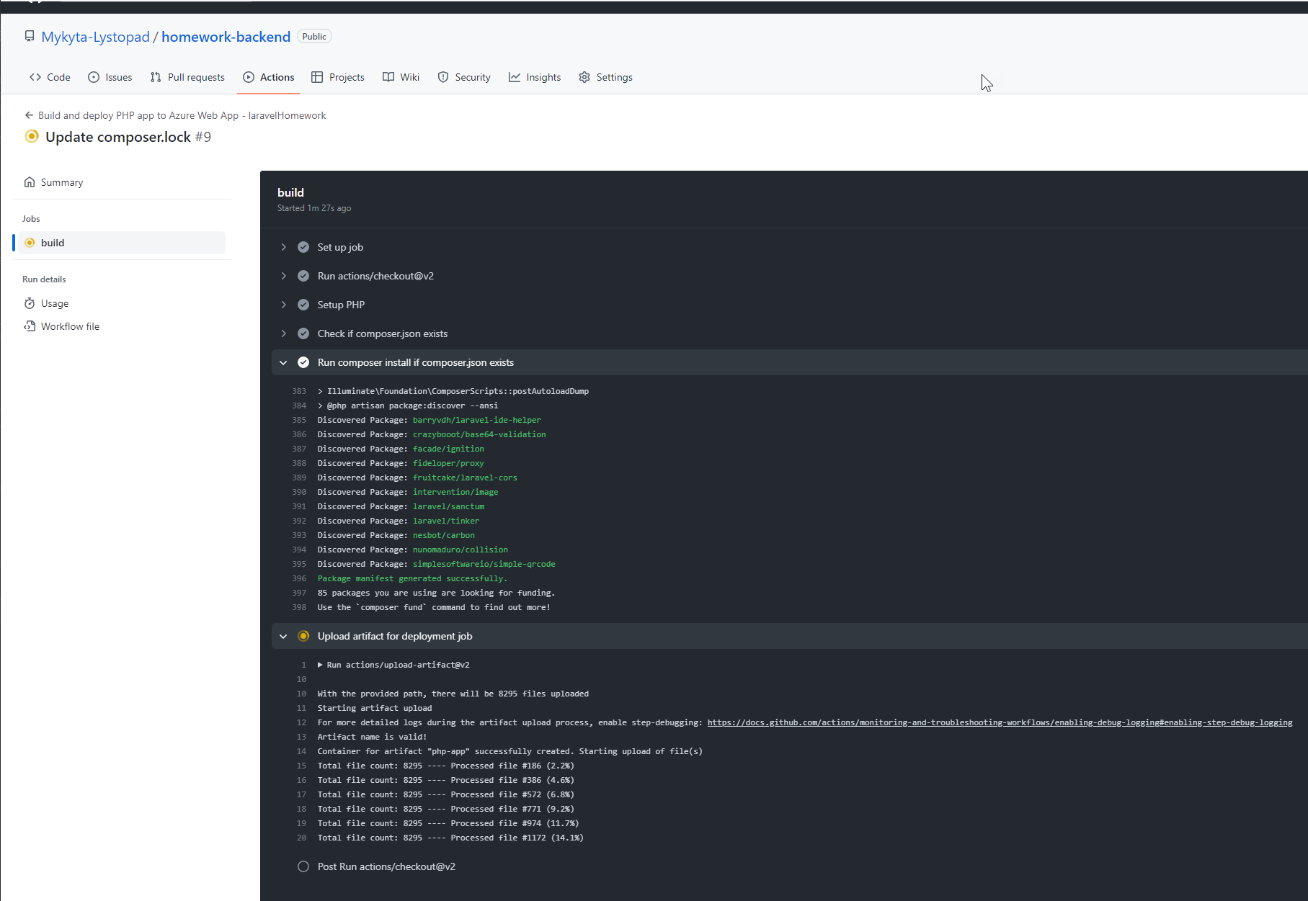

**Result:**

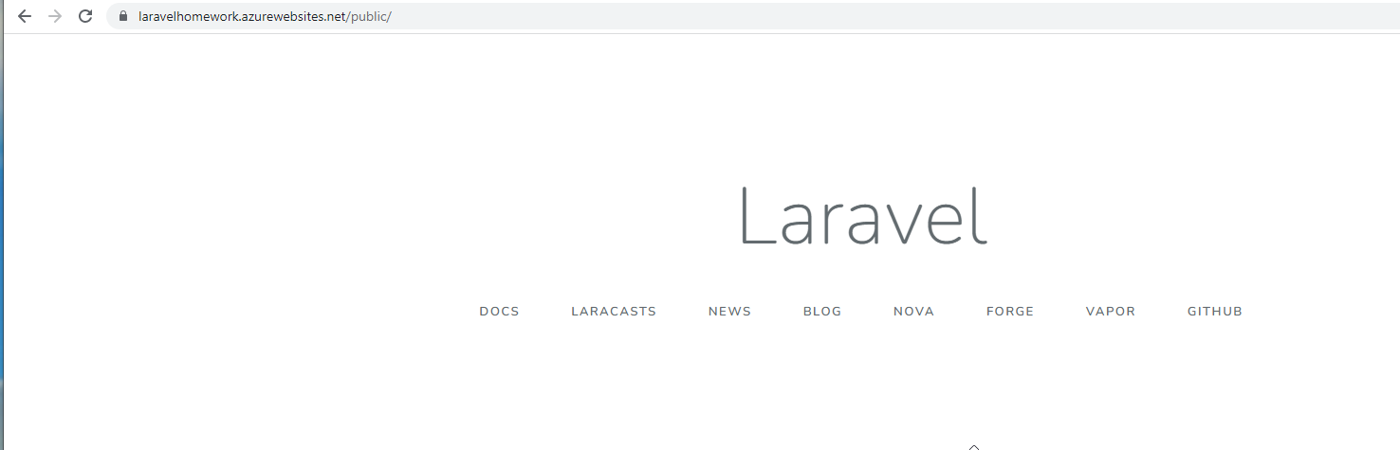

**Notes:**

**Rebuild application succeeds but does not update!**

WEBSITE_DYNAMIC_CACHE = 0

WEBSITE_LOCAL_CACHE_OPTION = Never

WEBSITE_WEBDEPLOY_USE_SCM = false

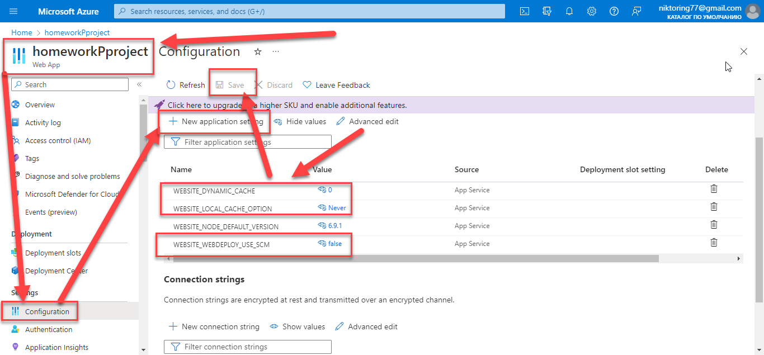

**After that stop an app**

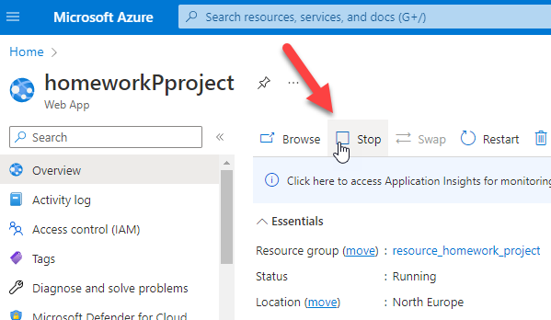

**Disable cache in browser and remove cookies files**

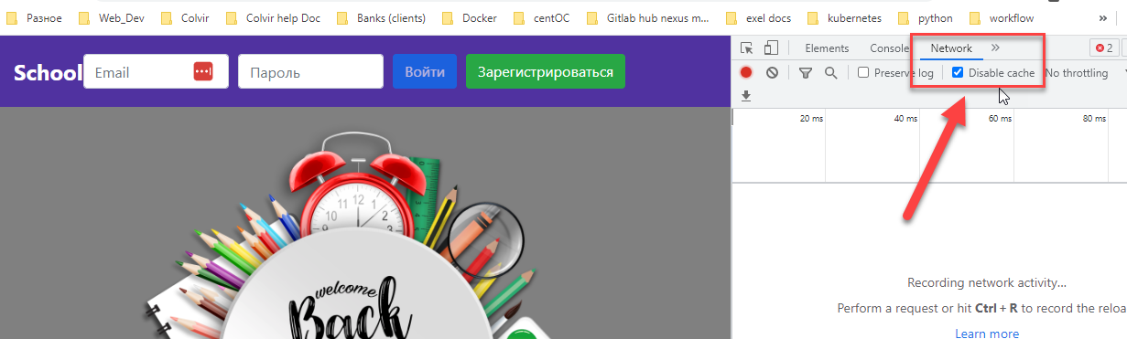

**Get commit to github or other way to rebuild your app**

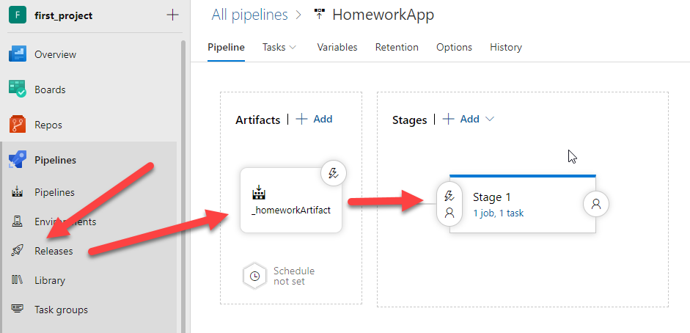

**Than start your app**

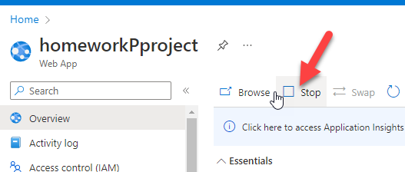

**Check your link or another way!**